**ABSTRACT:**

A bus reservation system is a database management system designed to manage and maintain bus schedules, reservations, and ticketing. The system is intended to be used by customers who wish to book a bus seat for a specific route. The database schema includes tables such as "Bus," "Route," "Seat," "Reservation," and "Customer" that store information related to buses, routes, available seats, customer details, and reservations.

The system allows customers to search for available buses on a particular route,

select a seat, and make a reservation. The system also supports cancellation of reservations and modification of existing reservations. The database management system includes features to handle ticket pricing, payment processing, and generating reports.

The bus reservation system is designed to be user-friendly and efficient, with a simple interface that enables customers to easily make reservations and view their bookings. The system is expected to provide reliable and accurate information to customers and administrators, ensuring smooth operations and a high level of customer satisfaction.

Online Bus Ticket Reservation System is a Web-based application that works within a centralized network. This project presents a review of the software program “Online Bus Ticket Reservation System” as it should be used in a bus transportation system, a facility which is used to reserve seats, cancellation of reservations and make different types of route enquiries used to secure quick reservations. This project is built for managing and computerizing the traditional database, ticket booking and tracking bus and travel made. It maintains all customer details, bus details, reservation details.

**TABLE OF CONTENTS:**

|  |  |  |
| --- | --- | --- |
| **S. NO** | **CONTENTS** | **PAGE NO** |
| 1. | Introduction |  |
| 2. | Literature Survey |  |
| 3. | System Architecture and Design |  |
| 4. | Modules and Fuctionalities |  |
| 5. | Coding and Testing |  |
| 6. | Result |  |
| 7. | Conclusion |  |
| 8. | References |  |

ABBREVATIONS:

**XML** Advanced Encryption Standard

**PHP** Hypertext PreProcessor

**CSS** Cascading Style Sheet

**HTML** HyperText Markup Language

**DB** Data Base

**RFID** Radio Frequency IDentification

**SQL** Structured Query Language

**UI** User Interface

1. **INTRODUCTION**
   1. **INTRODUCTION**

The bus reservation system is a computerized platform that facilitates the management of bus schedules, seat availability, ticketing, and other related functions. It is an efficient and effective solution for the transportation industry, providing a user-friendly interface that simplifies the process of booking a bus ticket.

The system comprises a database management system that stores and retrieves information related to buses, routes, seat availability, and customer details. It enables customers to search for available buses on a particular route, choose a seat, and make a reservation. The system also supports payment processing and generates reports related to revenue, passenger traffic, and other relevant metrics.

The bus reservation system has revolutionized the way people book bus tickets. In the past, customers had to physically visit a bus station or travel agent to make a reservation. However, with the advent of the bus reservation system, customers can make a reservation from the comfort of their own homes or offices. This has not only made the process of booking a bus ticket more convenient but has also helped to reduce long queues and waiting times at bus stations.

* 1. **PROBLEM STATEMENT:**

Travelling is a large business in India and other countries. Bus reservation system deals with the maintenance of records of details of each passenger who had reserved a seat for a journey. It provides a web-based bus ticket reservation function where a customer can buy a bus ticket through the online system without the need to queue up at the counter to purchase a bus ticket. It also enables customers to check the availability and types of buses online. Customers can check the time of departure for every bus through the system.

* 1. **OBJECTIVE:**

The main purpose of this study is to automate the manual procedures of reserving a bus ticket for any journey made through the application. This system is an automatic system and customers can select seats by themselves. Specifically, the objectives of this project will consist of:

* Providing a web-based bus ticket reservation function where a customer can buy a bus ticket through the online system without the need to queue up at the counter to purchase a bus ticket.
* Enabling customers to check the availability and types of buses online.
* Customers can check the time of departure for every bus through the system.
* Ability of customers to cancel their reservation.
* Admin user privileges in updating and cancelling payment, route and vehicle records
  1. **SCOPE AND APPLICATIONS:**

This system has mainly three actors.

* First is a user who books the bus seats gives the details and does the necessary payment option. He gets a token with all detail he boards the bus at a given time.
* The conductor who is staff will check the ticket and punch the confirmation.
* The owner checks the bills in the end. The user drops at the place of destination. Hence completes the task of the system.

The bus reservation system has several applications and is used in various contexts. Some of the most common applications of the bus reservation system are:

* **Passenger ticketing:** The bus reservation system is primarily used for passenger ticketing, enabling customers to search for available buses, select seats, and make reservations. The system also provides real-time updates on seat availability, enabling customers to plan their travel accordingly.
* **Bus scheduling:** The system is used by bus operators to manage and maintain bus schedules, ensuring that buses run on time and according to the planned route. This helps to improve the efficiency of bus operations and reduce delays and cancellations.
* **Revenue management:** The system enables bus operators to manage their revenue effectively, providing tools for pricing, inventory management, and payment processing. The system also generates reports on revenue, passenger traffic, and other metrics, enabling bus operators to make informed decisions about pricing and route planning.
* **Customer service:** The system provides a platform for customer service, enabling customers to make inquiries, file complaints, and request refunds. The system also provides tools for customer feedback and helps to improve the overall customer experience.
* **Marketing and promotion:** The system can be used by bus operators for marketing and promotion, providing tools for advertising, social media integration, and loyalty programs. The system can also be used to track customer behavior and preferences, enabling bus operators to tailor their services to meet customer needs.

Overall, the bus reservation system is an essential tool for the transportation industry, providing a range of applications that help to improve the efficiency and effectiveness of bus operations. It has significantly improved the customer experience and has helped bus operators to increase their revenue and profitability.

* 1. **GENERAL AND UNIQUE SERVICES:**
* Admin user can add routes, buses, fare update and maintain all the functionalities of the website.
* If a user needs to go from A to B and there are no direct routes, our program will give out the cheapest indirect route and the fastest indirect route, upto to the user to decide.
* Rest functionalities like, booking ticket, checking fares, seat booking, payment online through trusted gateways exist.

Unique services are-

1. **Real-time seat availability:** The bus reservation system provides real-time updates on seat availability, enabling customers to choose their preferred seats and plan their travel accordingly.
2. **Mobile booking:** The bus reservation system offers mobile booking, allowing customers to make reservations and purchase tickets through their smartphones or tablets. This provides a convenient and efficient way for customers to book tickets while on the go.
3. **Loyalty programs:** Some bus reservation systems offer loyalty programs, providing incentives for frequent travellers, such as discounts, priority boarding, and other perks.
4. **Multi-language support:** The bus reservation system may offer multi-language support, enabling customers to interact with the system in their preferred language. This is especially useful for customers who speak languages other than the primary language used in the system.
5. **Customization:** Some bus reservation systems offer customization options, allowing bus operators to tailor the system to their specific needs and requirements. This can include custom branding, pricing rules, and other features.
6. **Integration with other systems**: The bus reservation system can be integrated with other systems, such as payment processing systems, accounting systems, and other third-party applications. This enables bus operators to streamline their operations and improve their efficiency.
   1. **SOFTWARE REQUIREMENTS:**

**Hardware**

● A computer system that can access all the tools and is a Pentium D 1.2Ghz or better

● 2048 Megabytes of RAM

● Linux

**Software**

● Kate/Notepad++

● Apache2/PHP/MySqli

● SQL Server 2005/2008 RTM

● PhpMyAdmin

**2)LITERATURE SURVEY:**

There are several research studies and articles that discuss the bus reservation system and its impact on the transportation industry. Here is a brief literature survey of some of the most relevant studies:

"Design and Implementation of an Online Bus Reservation System for Inter-City Travel in Nigeria," by Olumide S. Adewale and Adeyemi O. Adeyemo. This study describes the design and implementation of an online bus reservation system for inter-city travel in Nigeria. The study highlights the benefits of the system, including increased efficiency, reduced costs, and improved customer experience.

"Analysis of the Impact of the Internet on the Bus Reservation System," by Jianmin Zhu. This article analyzes the impact of the internet on the bus reservation system, highlighting the advantages and disadvantages of online booking. The study concludes that online booking has improved the efficiency of the bus reservation system and has provided customers with greater convenience and flexibility.

"Application of Bus Reservation System Based on Service-Oriented Architecture," by Qingyue Li. This study proposes a bus reservation system based on a service-oriented architecture (SOA). The system is designed to improve the scalability, flexibility, and availability of the bus reservation system. The study concludes that the proposed system is more efficient and reliable than traditional bus reservation systems.

"A Review of Bus Reservation System," by Kavitha R. and G. Saravana Kumar. This article provides a review of the bus reservation system, highlighting the benefits and challenges of the system. The study concludes that the bus reservation system has revolutionized the way people book bus tickets and has improved the overall customer experience.

"Modeling and Analysis of Bus Reservation Systems," by Ganesh R. and Arun P. This study proposes a mathematical model for the bus reservation system, which can be used to optimize bus schedules and ticket pricing. The study concludes that the proposed model can improve the efficiency and profitability of the bus reservation system.

Overall, the literature survey highlights the importance of the bus reservation system in the transportation industry and its impact on improving efficiency, reducing costs, and improving the customer experience. The studies also suggest that further research is needed to optimize the bus reservation system and to improve its effectiveness and efficiency.

3)**SYSTEM ARCHITECTURE AND DETAILS:**

**3.1) ARCHITECTURE DIAGRAM:**

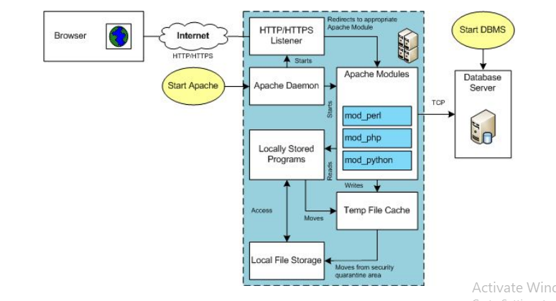

**3.1.1) FRONT END (UI) DESIGN:**

**BUS RESRVATION SYSTEM**

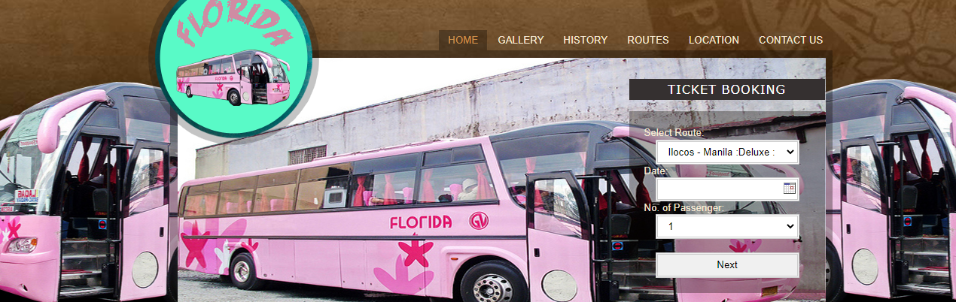

**LOGIN PAGE**

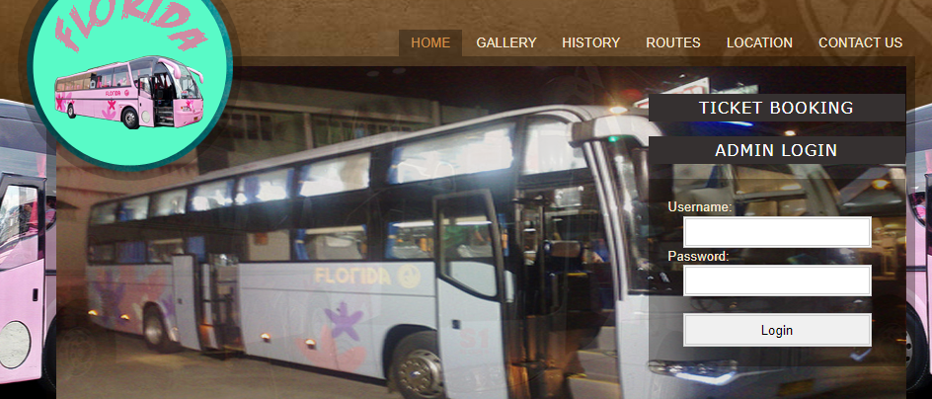

**ADMINISTRATOR LOGIN**

**3.1.2) BACKEND (DATABASE DESIGN)**

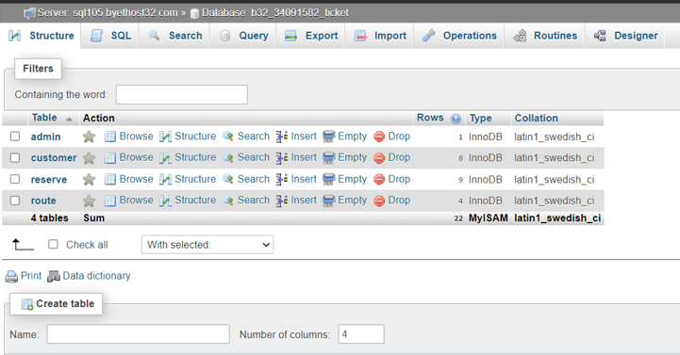

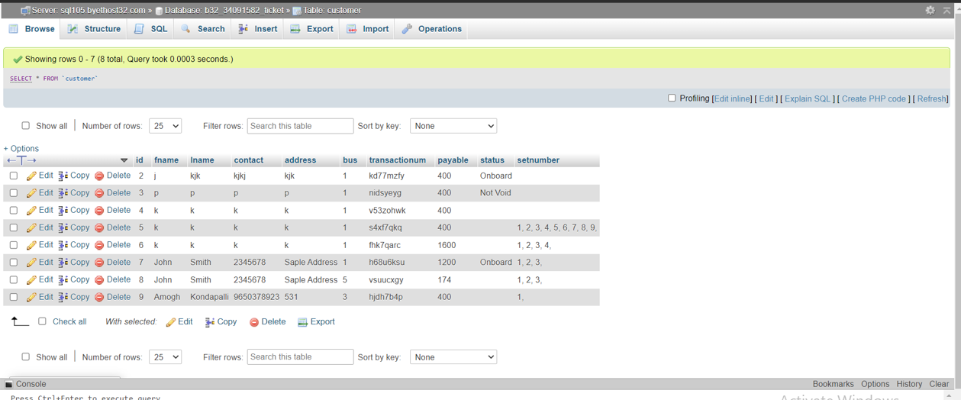

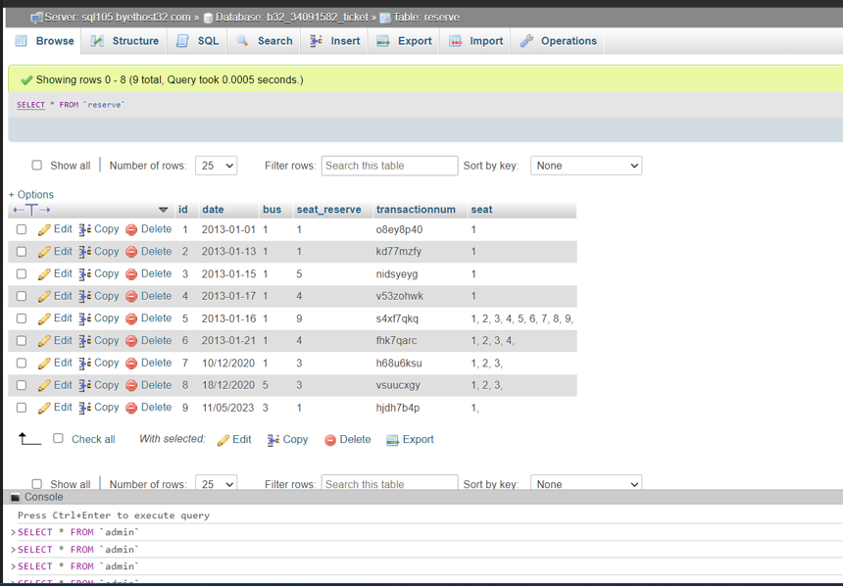

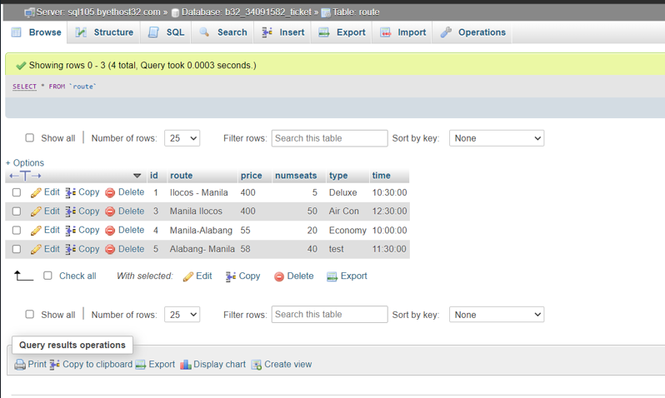

**DATABASE DESIGN**

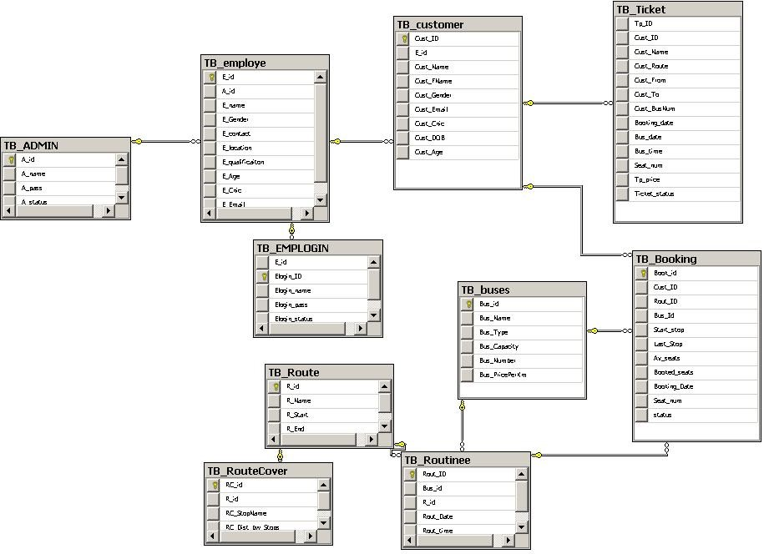

**3.2) ER DIAGRAM AND USE CASE DIAGRAM:**

**ER DIAGRAM**

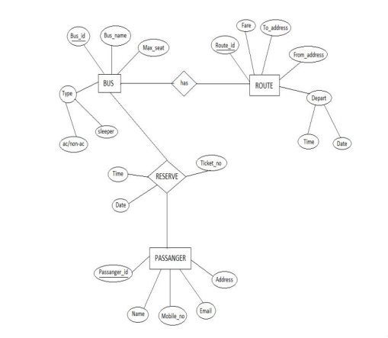

**USE CASE DIAGRAM**

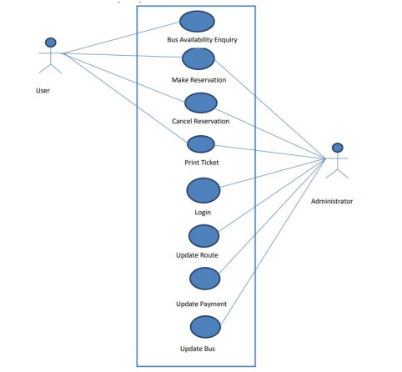

**4) MODULES AND FUCTIONALITIES:**

This module includes:

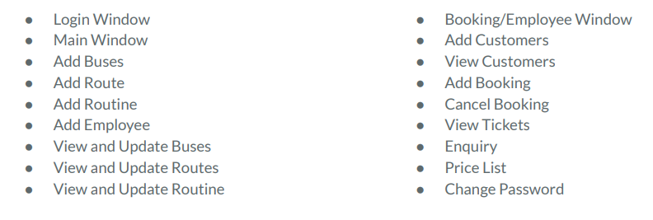

4.1.1) INDEX PAGE:

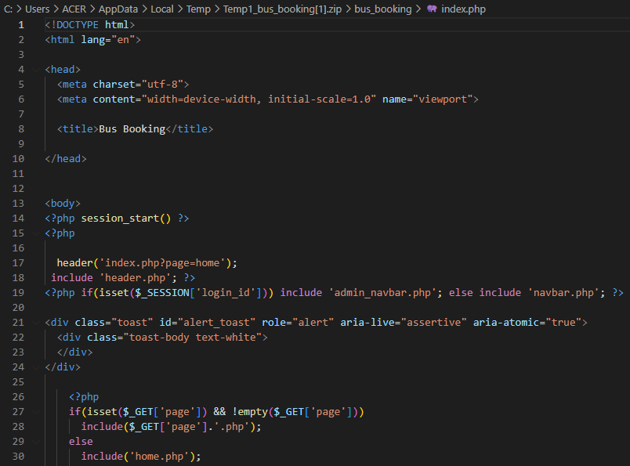

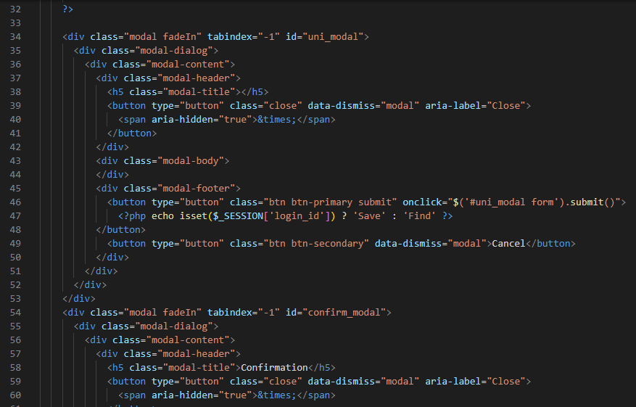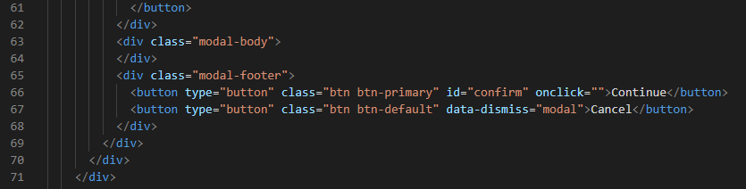

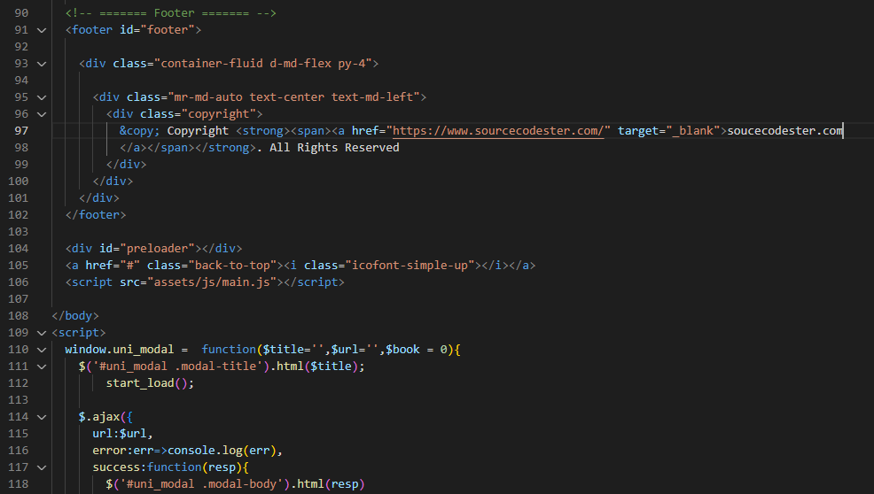 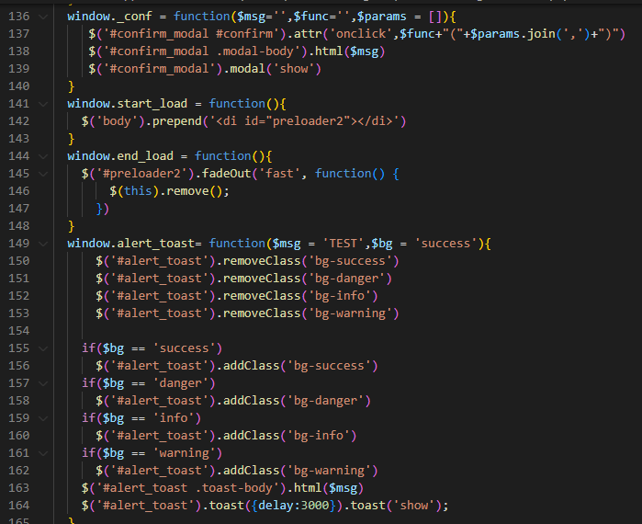

4.1.2) HOME PAGE:

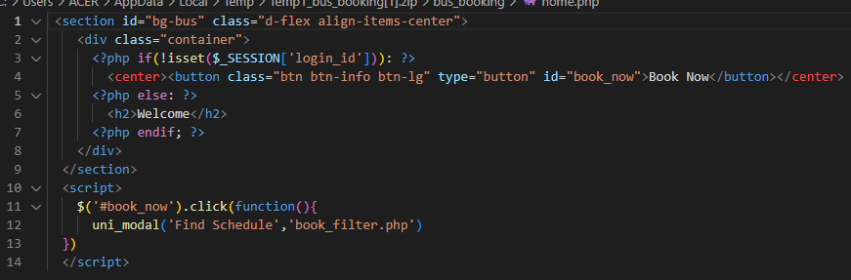

4.1.3) LOGIN AUTHORIZATION:

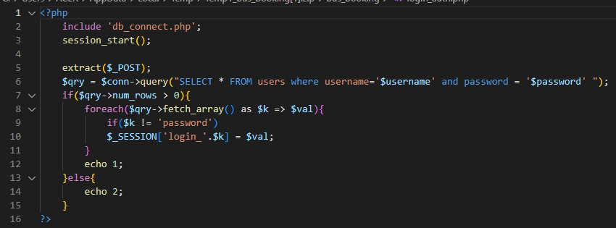

4.1.4) CUSTOMER_BOOKING PAGE: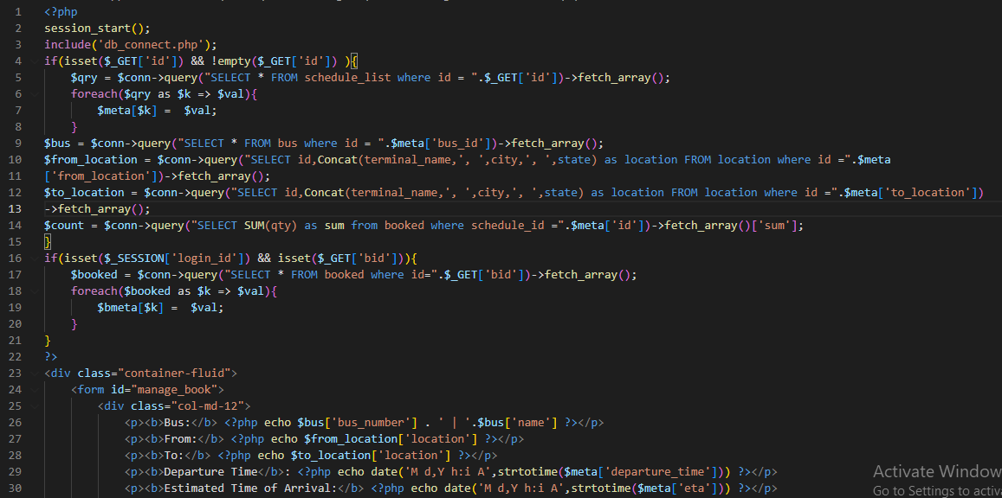 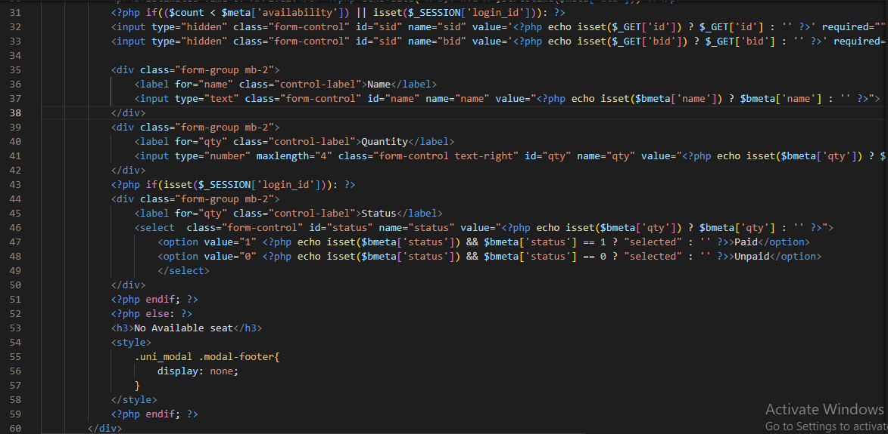

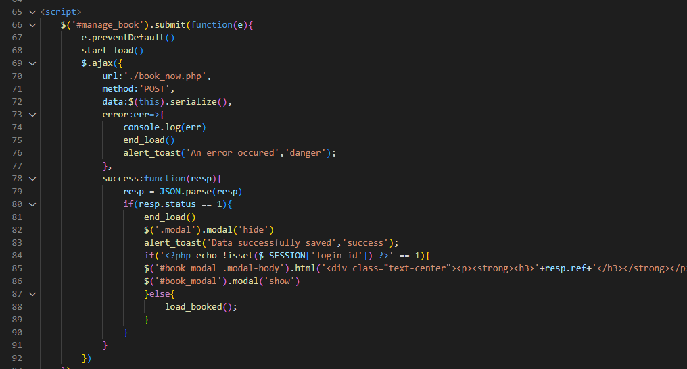

4.1.5)ADMIN_PAGE:

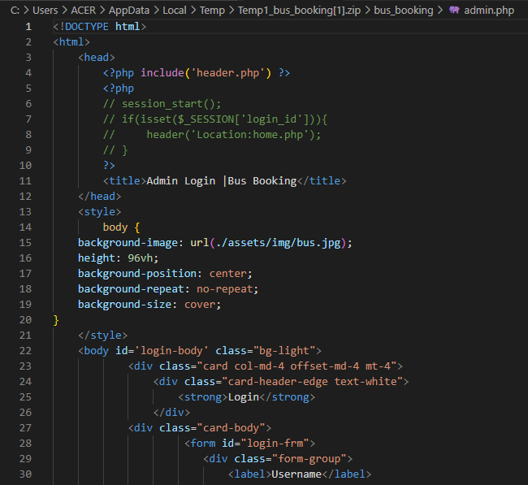

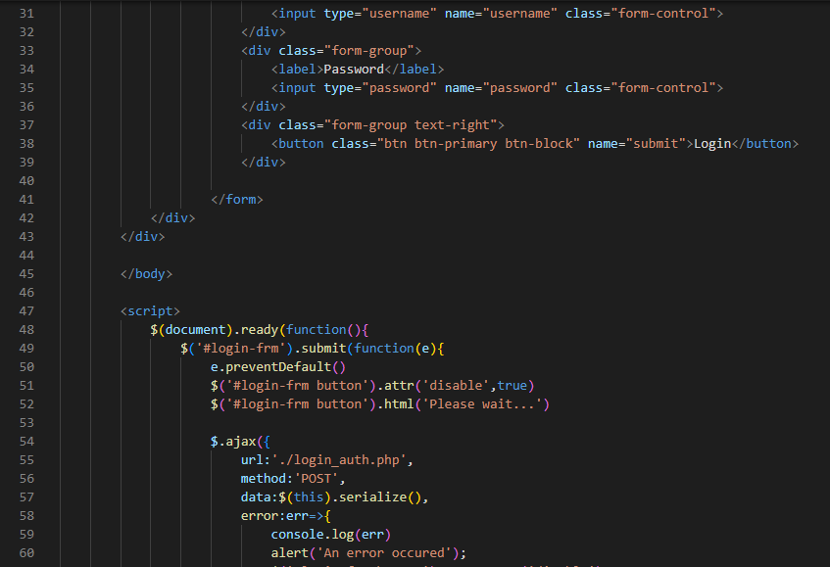

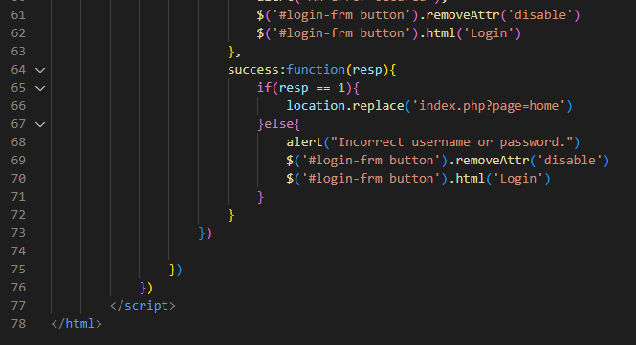

4.1.6) ADMIN NAVBAR:

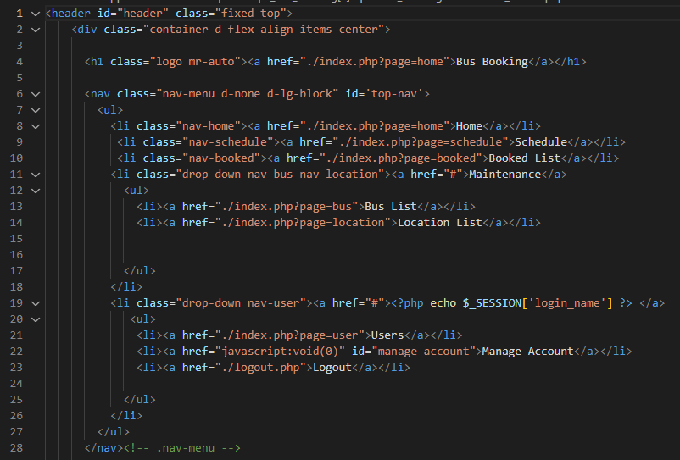

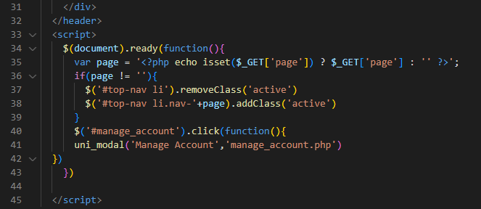

4.1.7) BOOK NOW PAGE:

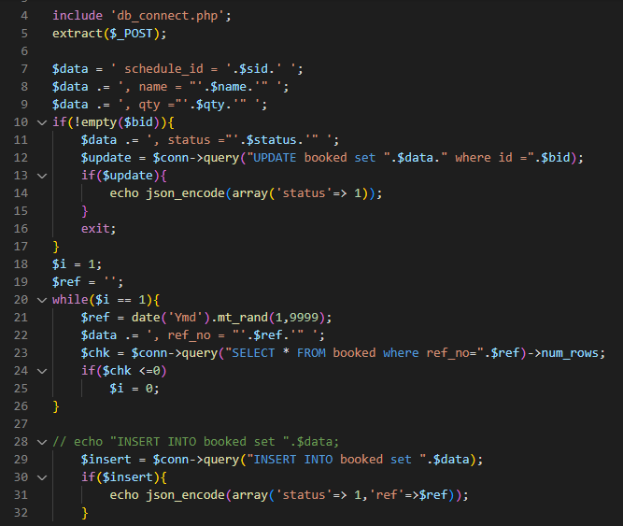

4.1.8) DELETE BUS:

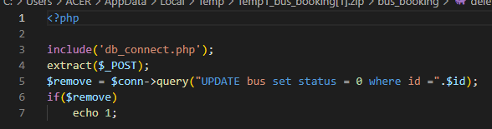

4.1.9) DELETE USER:

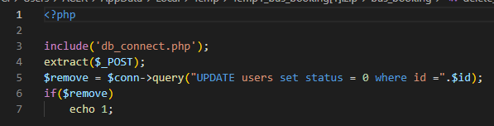

4.1.10) LOOD BOOKED:

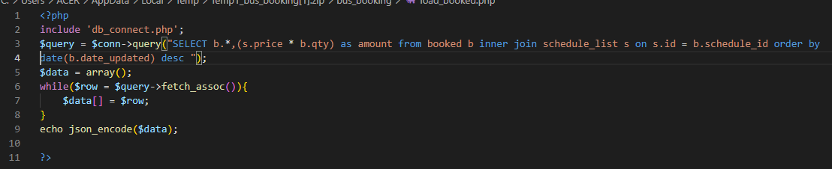

4.1.11) MANAGE ACCOUNT:

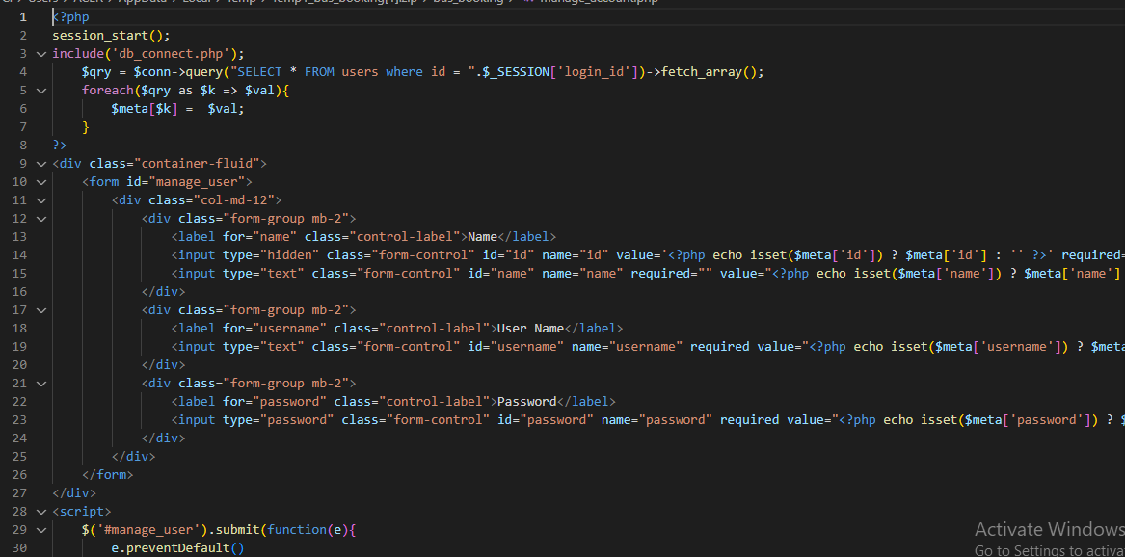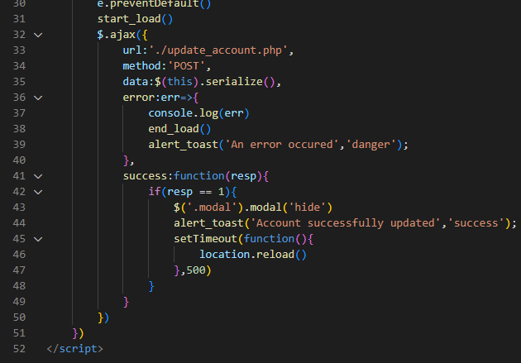

4.1.12) UPDATE ACCOUNT:

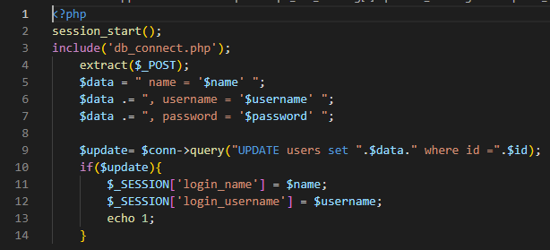

4.1.13)SAVE SCHEDULE:

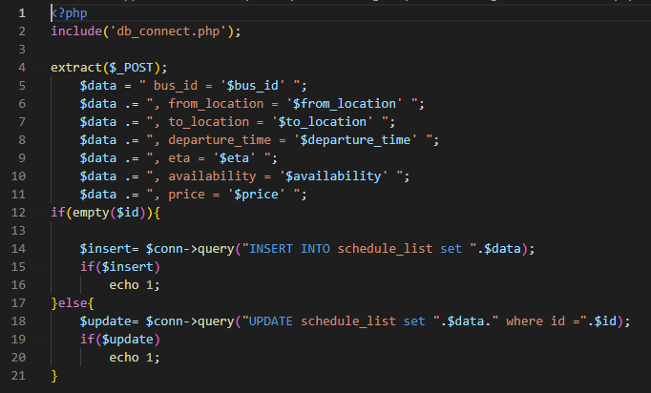

4.1.14) LOGOUT:

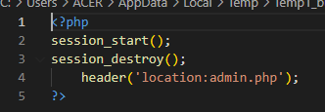

**TESTING:**

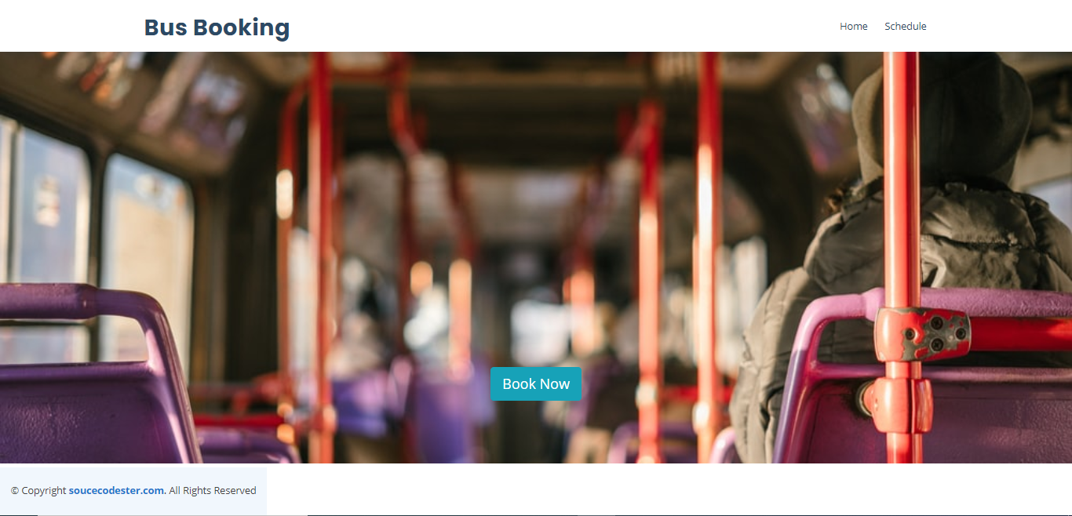

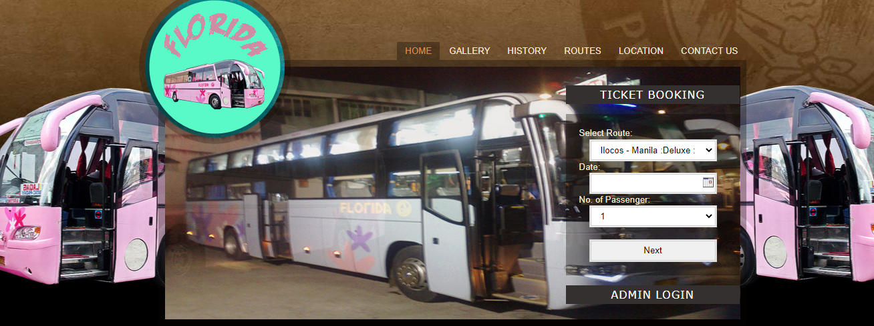

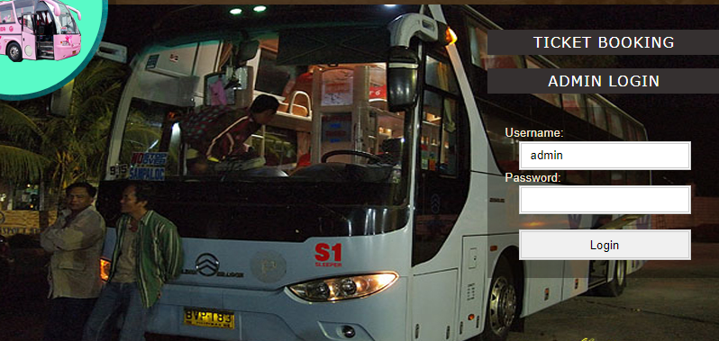

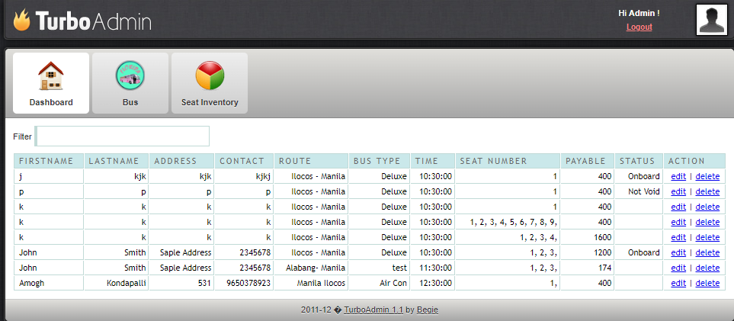 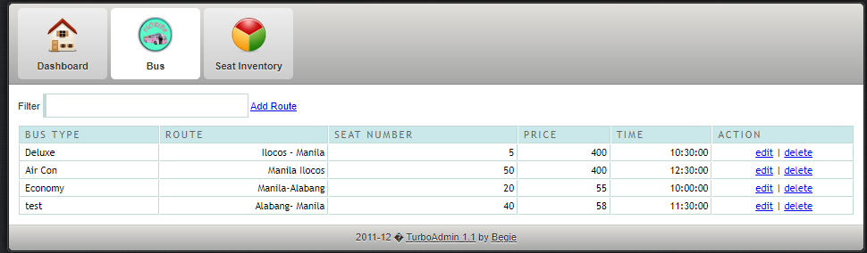 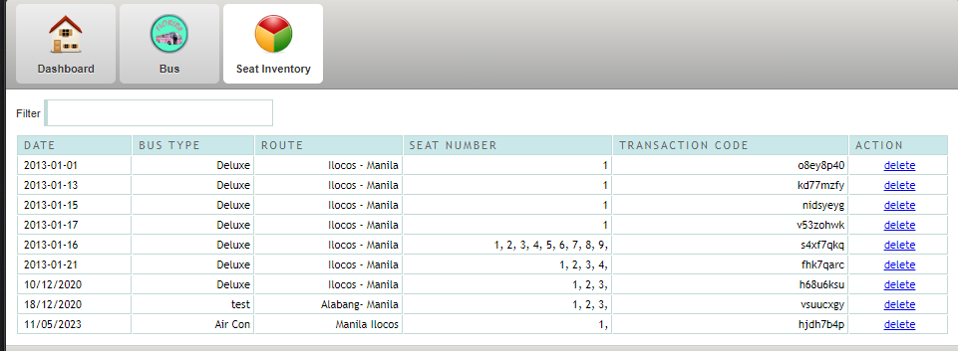

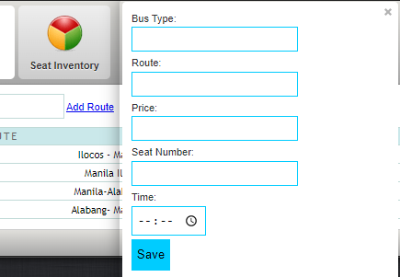

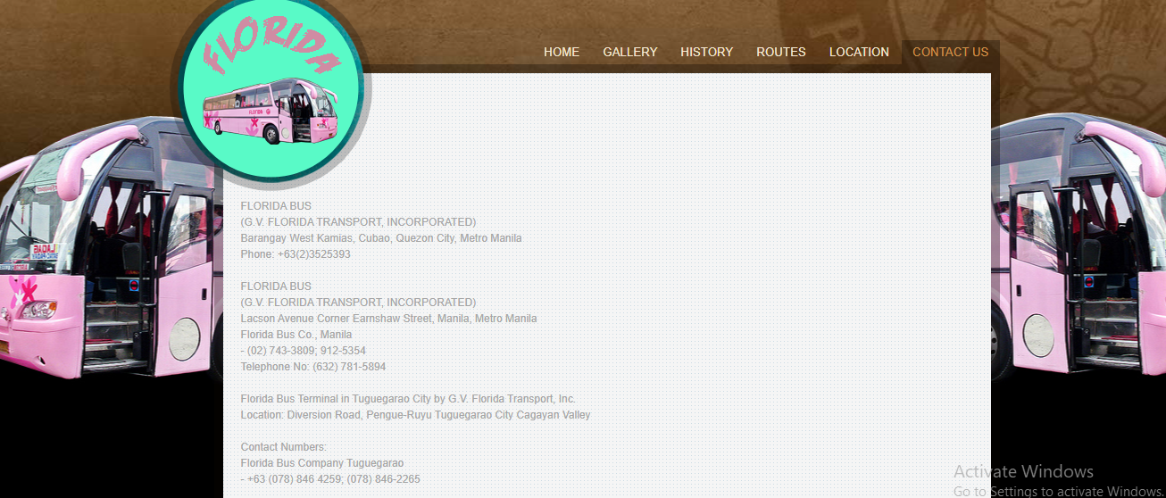

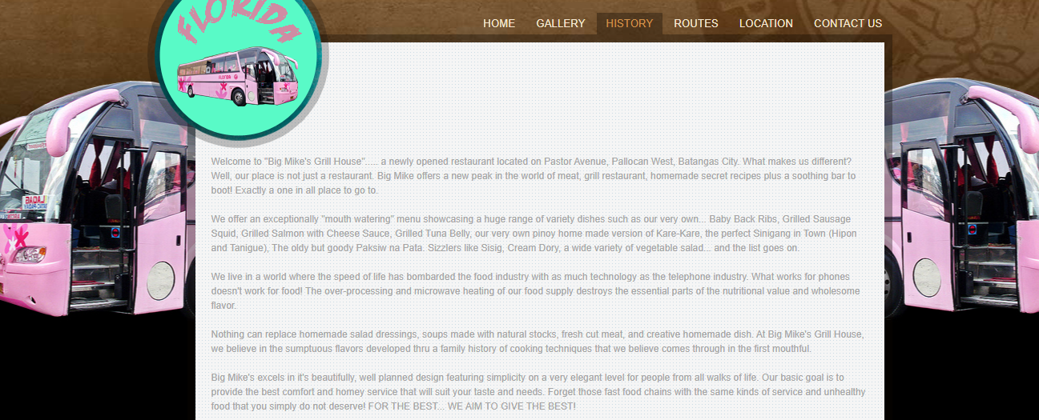

**6.RESULT:**

* Welcome Page features a bus reservation system and multiple login options, including admin login and distributor log in. The welcome screen displays the tickets booking with the words "welcome log in". This comprehensive system aims to streamline the booking process and improve efficiency within the bus station environment.
* Distributor Panel is used to manage bookings and update status order data such as edit, deleting , seat inventory , and log out.
* Booking Manager Panel has many uses for managers in terms of controlling inventory and sustaining customer interactions.

* Administrator Panel is for the bus booking management staff to maintain all of the options around the country at one single interface.

And from the above attached screenshots these pages and databases for the bus reservation system is implemented successfully.

**7.CONCLUSION:**

In conclusion, the bus reservation system is a critical tool for the transportation industry, providing a range of applications that help to improve the efficiency and effectiveness of bus operations. The system offers several unique services, including real-time seat availability, mobile booking, loyalty programs, multi-language support, customization options, and integration with other systems.

The literature survey highlights the benefits of the bus reservation system, including increased efficiency, reduced costs, and improved customer experience. The studies suggest that the bus reservation system has revolutionized the way people book bus tickets and has significantly improved the overall efficiency and profitability of the transportation industry.

However, there are still some challenges associated with the bus reservation system, including technical issues, security concerns, and operational challenges. Therefore, there is a need for further research and development to optimize the bus reservation system and to improve its effectiveness and efficiency.

Overall, the bus reservation system has had a significant impact on the transportation industry, providing a reliable and efficient platform for managing bus schedules, ticketing, and related functions. It has improved the customer experience and has helped bus operators to increase their revenue and profitability. The bus reservation system is expected to continue to evolve and improve in the future, driven by advances in technology and changing customer needs and preferences.

**7.REFERENCES:**

1. Asad, A.A., Ayad, M.J. and Hayder, N.K. (2012). Design and Developing Online Iraqi Bus Reservation System Using Unified Modeling Language. International Journal of Scientific knowledge Available at: [http://www.ijsk.org/uploads/3/1/1/7/3117743/v3i103_information_technology.pdf Accessed 13th December 2014](http://www.ijsk.org/uploads/3/1/1/7/3117743/v3i103_information_technology.pdf%20Accessed%2013th%20December%202014)

2. Gayathry, S. (2013). Online Bus Ticketing System: Tactful Management Research Journal Through Case Studies.RedBus.in

3. Goessl, L. (2009). Business Advantages of a Relational Database. Available at: <http://www.insidebusiness360.com/index.php/business-advantages-of-a-relational-database-15806/>

4. Invaderzim08, (2011).Online Bus Reservation System. Retrieved from [http://www.studymode.com/essays/Bus-Reservation-System-741084.html Accessed 20th November 2014](http://www.studymode.com/essays/Bus-Reservation-System-741084.html%20Accessed%2020th%20November%202014)

5. Maike, J.P. (2014). Train, bus and museum - Interrelations of diverse actors within integrated E - ticketing schemes. Available at: http://www.mobil-tum.vt.bgu.tum.de/fileadmin/w00bqi/www/Session_Poster/Puhe.pdf Accessed 16th October 2014